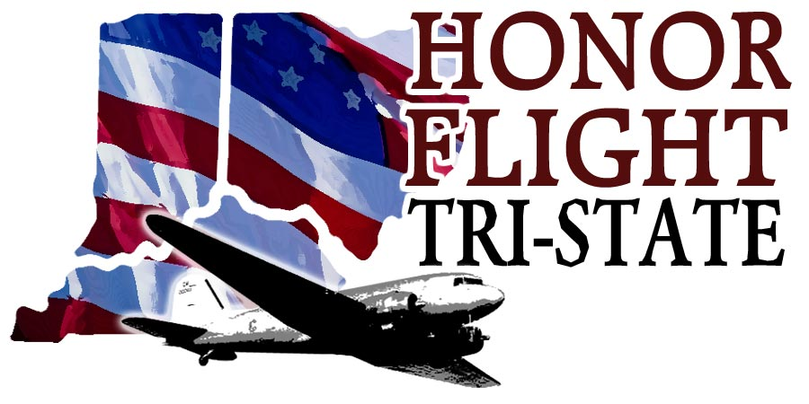

Headquarters
8627 Calumet Way
Cincinnati, OH 45249
www.honorflighttristate.org

“Flightless Honor Flight” Veteran Application

To participate in the Flightless Honor Flight Program, please fill out the following form so our Ambassadors and ground crew can serve all of your needs.

You will be sent a letter of confirmation and further information after you are accepted. You and your escort will then receive “Flightless Honor Flight” tickets to the virtual tour and program. You must present these tickets on the day of the program for access to the program.

Name ___________________________________( as it appears on your photo ID )

Age _____________________ Phone Number ______________________

Address _____________________________________ T-shirt size ___________

City ____________________ State _________ Zip Code ________________

Email address if you have one _________________________________________

Branch of Service: _____________________Rank______________________

WW ll _______Korean War _________ Vietnam War ________ Other _________

Do you need a wheelchair? ______________Do you use a scooter? ___________

Can you walk unassisted? ______________________

Do you use oxygen? _____________

ESCORT information

Who will be bringing you to the Flightless Program?

_____________________________________

Is that person going to be your escort for the program? ______________________

My escort’s full name ________________________________________________

Phone number for the escort _________________________________

Email address of the escort __________________________________

Escort’s address ___________________________________________

City _______________________State __________ Zip code _________

I understand this program is offered as a courtesy by Honor Flight Tri-State for veterans who are unable to travel on a regular Honor Flight trip. All medical insurance and liability is assumed by the veteran/escort. Honor Flight Tri-State does not provide medical care. I understand and accept responsibility for any illnesses or injuries incurred while participating in the Honor Flight Flightless Program.

Veteran’s Signature ________________________________Date ___________

Escort’s Signature __________________________________Date __________

I understand as photographic and video equipment are frequently used to memorialize and document Honor Flight Tri-State trips and events, my image may appear in a public forum, such as the news media or a website, to acknowledge or promote the work of the Honor Flight Tri-State Program. I hereby release the photographer and Honor Flight Tri-State from all claims and liability relating to said photographs. I hereby give my permission for my image captured during the Honor Flight Tri-State Activities through video, photos or other media, to be used solely for the purposes of Honor Flight Tri-State promotional materials and publications, and waive any rights, compensation or ownership thereto.

Veteran’s Signature ________________________________Date ___________

Escort’s Signature __________________________________Date __________

Please forward the completed form to Honor Flight Tri-State headquarters:

Honor Flight Tri-State
Attention: Dee Daniels (Flightless Honor Flight)
8627 Calumet Way
Cincinnati, OH 45249

